**EX.NO: 2 DESIGN ENTRY AND SIMULATION OF SEQUENTIAL LOGIC CIRCUITS**

**DATE:**

**AIM:**

To design and simulate the sequential logic circuits (Flip-flops, Counters & Registers) using Verilog module Xilinx Vivado Webpack.

**SOFTWARE REQUIRED:**

Vivado Design Suite WebPACK™ Edition

**a) FLIP-FLOPS:**

**(i) SR FLIP-FLOP:**

**Logic Circuit**

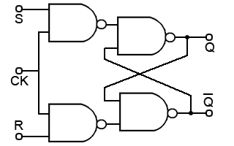

**Truth Table**

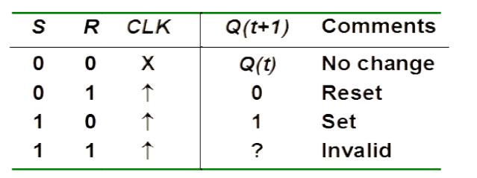

**PROGRAM:**

a) GATE LEVEL MODELING:

b) DATAFLOW MODELLING:

c) BEHAVIORAL MODELLING:

**SIMULATION OUTPUT:**

**(ii) JK FLIP-FLOP:**

**Logic Circuit**

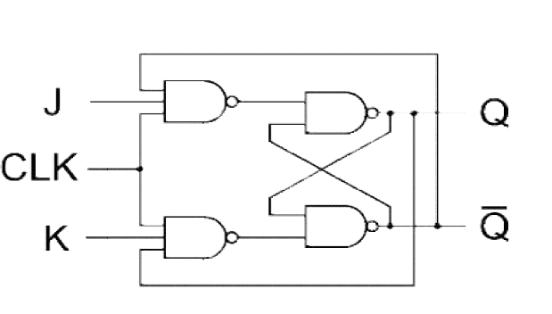

**Truth Table**

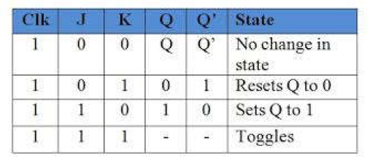

**PROGRAM:**

a) GATE LEVEL MODELING:

b) DATAFLOW MODELLING:

c) BEHAVIORAL MODELLING:

**SIMULATION OUTPUT**

**(iii) D flip flop**

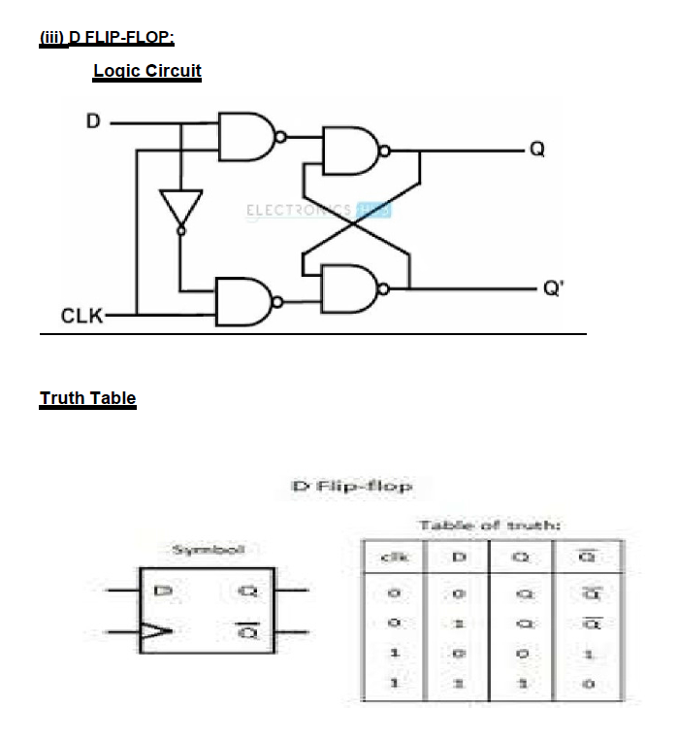

**(iv) T-Flip Flop**

